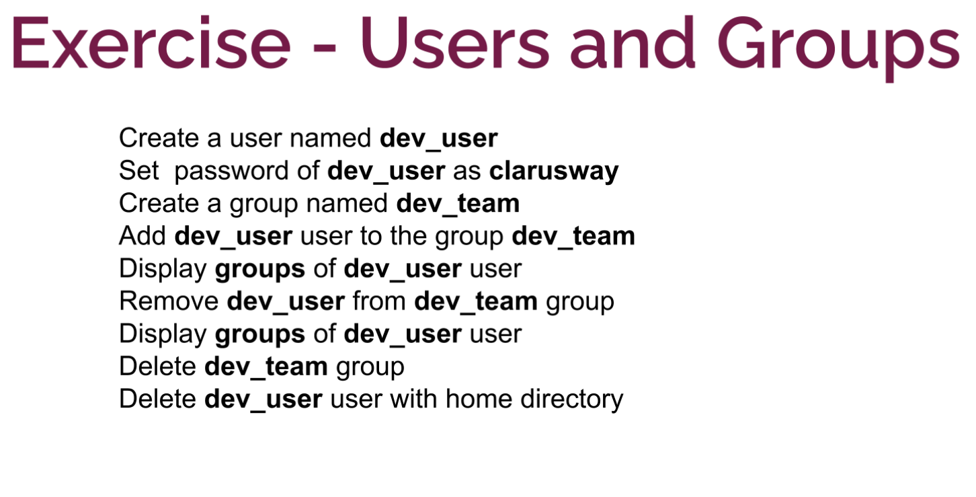

sudo sudo

useradd dev-user

# etc klasoru icinde kullanicilari gorebiliriz.

cat passwd

passwd dev-user

# cat group gruplari grebiliriz.

groupadd dev-team

gpasswd -a dev-user dev-team

groups dev-user

gpasswd -d dev-user dev-team

groups dev-user

groupdel dev-team

userdel -r dev-user # -r home klasorunude siler.

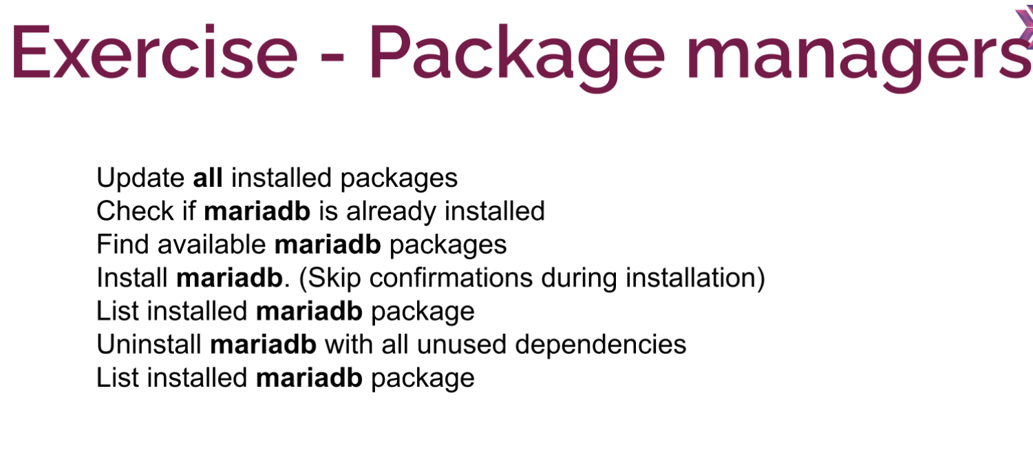

sudo yum update -y

sudo yum list installed mariadb

sudo yum list mariadb

sudo yum list installed mariadb

sudo yum autoremove mariadb -y

sudo yum list installed mariadb

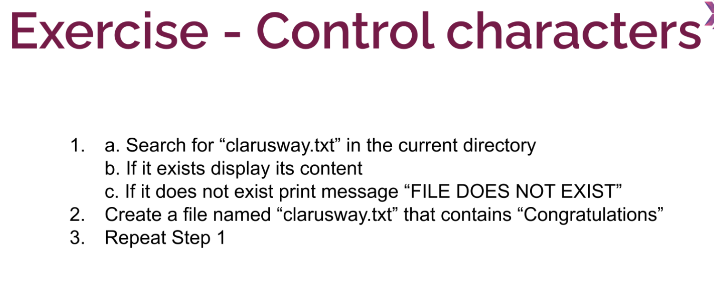

sudo su

ls clarus*

ls clarusway.txt && more clarusway.txt

cat clarusway.txt

ls clarusway.txt && more clarusway.txt || echo “FILE DOES NOT EXIST”

vim clarusway.txt

i

Congratulations

ESC

:wq

ls clarus*

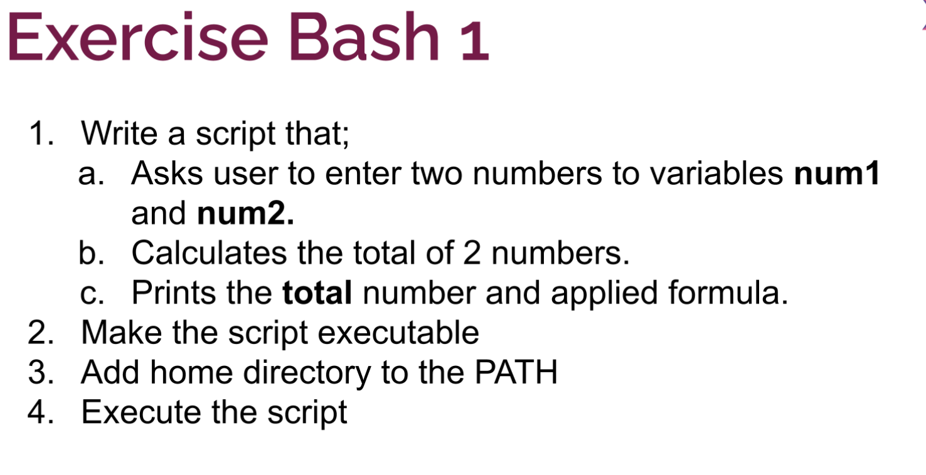

#!/bin/bash

read -p “Enter a number” num1 num2

let total=$num1 + $num2

print($total)

chmod +x bash1.sh

export PATH=$PATH:/~ # home klasorunu bin altinda olusturdugummuzdan ./ gerek yok

bash1.sh

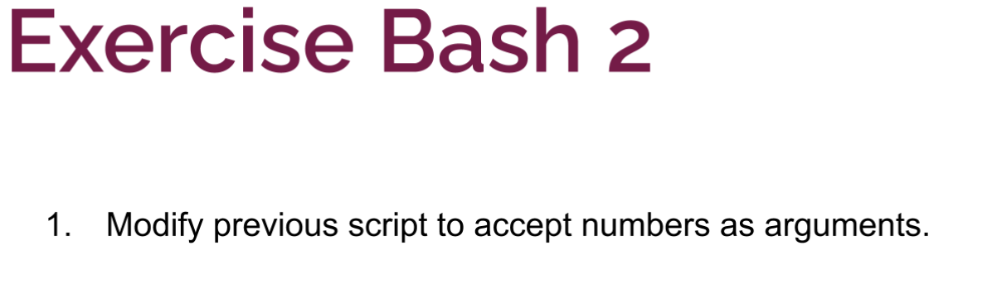

#!/bin/bash

Echo “SAyilarin Toplami: $(($1 + $2))

chmod +x bash2.sh

./bash2.sh

bash2.sh 11 22

33

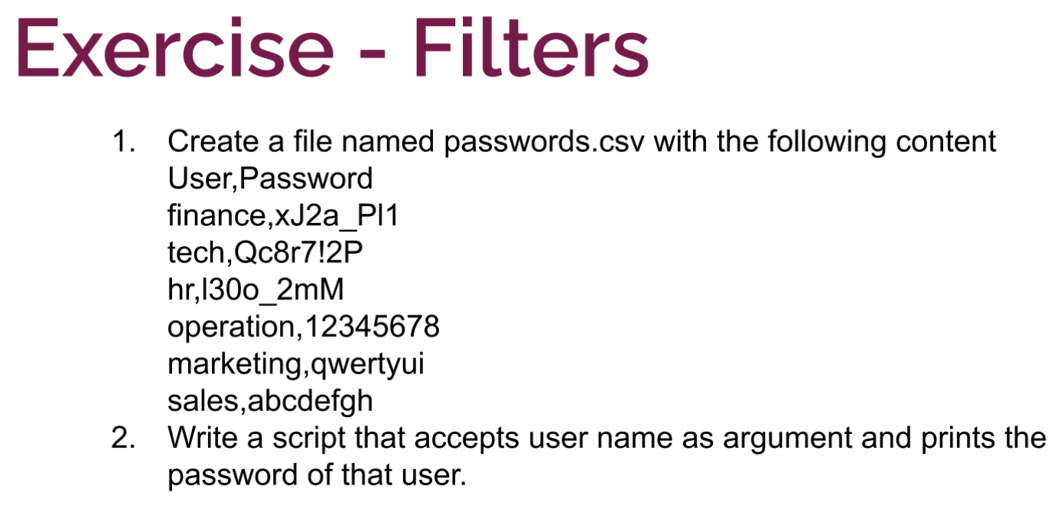

vim passwords.csv

User,Password

finance,xJ2a_Pl1

tech,Qc8r7!2P

hr,l30o_2mM

operation,12345678

marketing,qwertyui

sales,abcdefgh

#!/bin/bash

passwd=$(cat password.csv | grep $1 | cut -d’,’ -f2)

echo “password of $1 : $passwd”

chmod +x bash3.sh

./bash3.sh hr

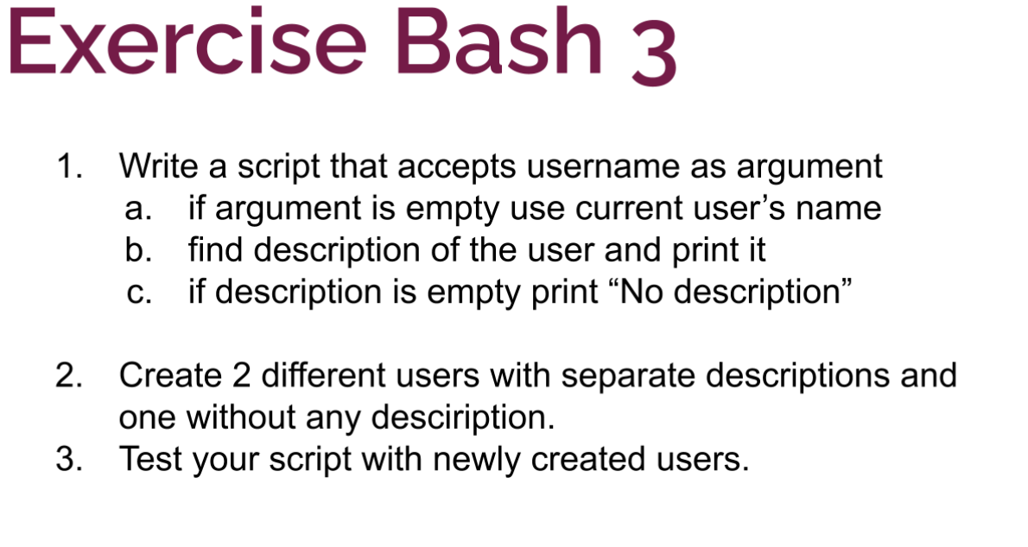

#!/bin/bash

username=$(whoami)

if [ $1 ]

then

username=$1

fi

description=$(cat /etc/passwd | grep $username | cut -d":" -f5)

if [ "$description" != "" ]

then

echo "Description of $username is $description"

else

echo "No description for user $username"

fi

sudo useradd hr -c “Human Resources Section”

sudo useradd tech -c “Technical Stuff”

sudo useradd aws

**************

#!/bin/bash

username=$(whoami)

if [ $1 ]

then

username=$1

fi

description=$(cat /etc/passwd | grep $username | cut -d":" -f5)

if [ "$description" != "" ]

then

echo "Description of $username is $description"

else

echo "No description for user $username"

fi

get_password $username #bu bizim önceki alıştırmada oluşturduğumuz script. burada doğrudan çağırıyoruz.

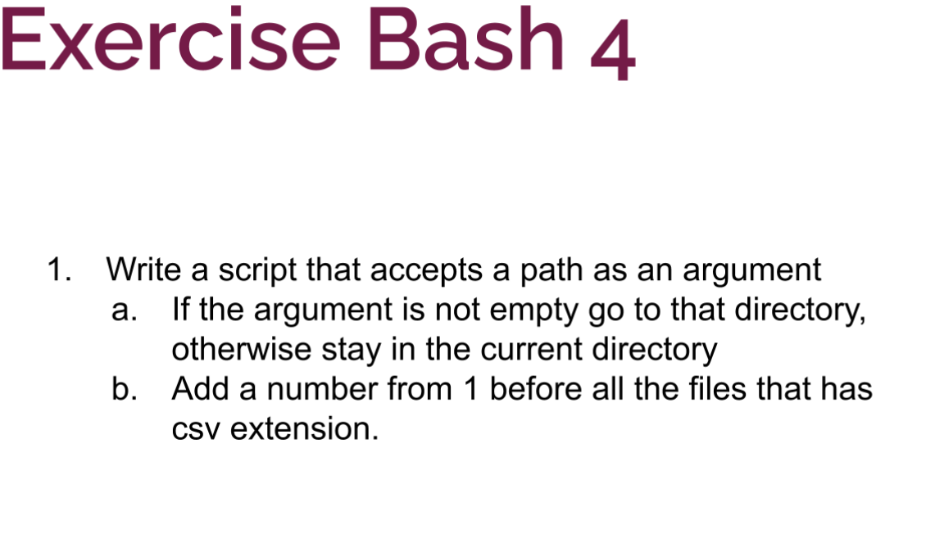

if [ $1 ]

then

cd $1

fi

number=1

for FILE in *.csv

do

mv $FILE $number-$FILE

let number++

done

mkdir new

touch test.csv sec.csv third.csv test.txt

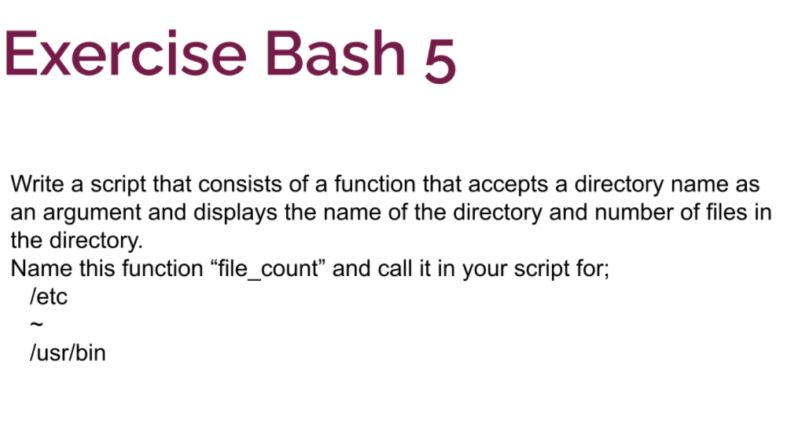

function file_count()

{

local Directory=$1

COUNT_FILE=$(ls $Directory|wc -l)

echo "$Directory - $COUNT_FILE"

}

file_count /etc

file_count ~

file_count /usr/bin